Transactional Replication

Create two folders on Subscriber server for subscriber database and snapshot and gave permission to user under which sql services are running. (if required)



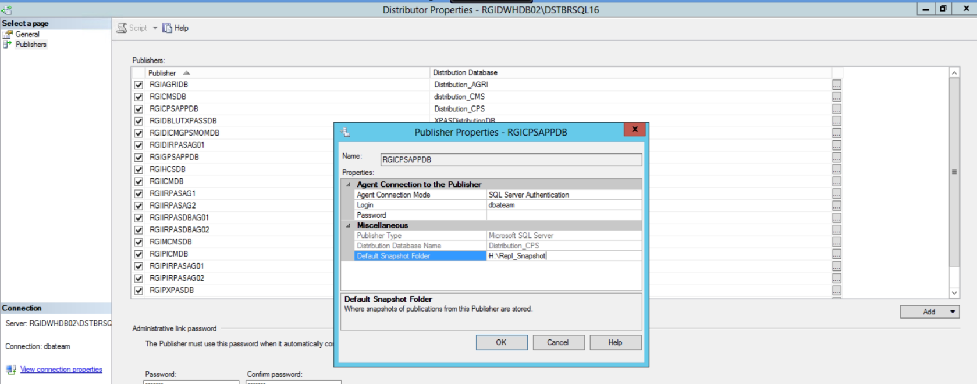

1 Connect distributor server with server name without port

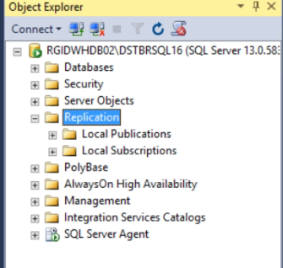

2 Open distributor properties and then click on general

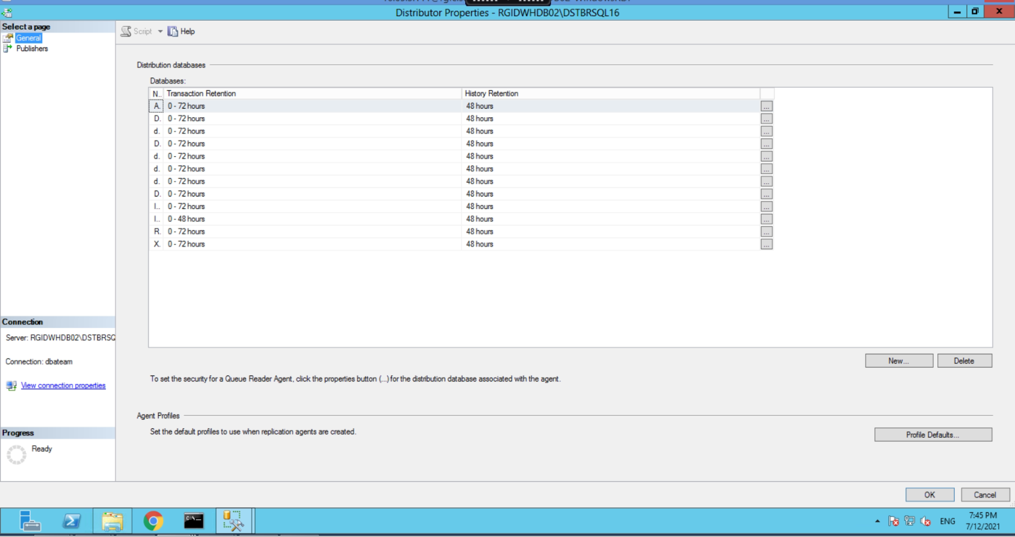

3 new distributor database name and location and then ok.

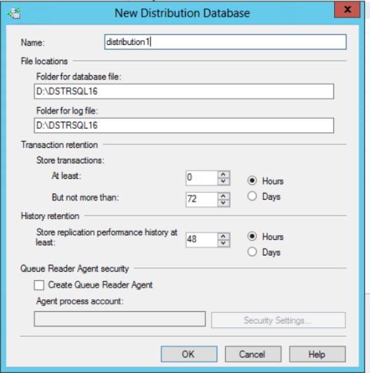

4 Again distribution properties and then click publisher and add publisher and connect to Publisher server without port and add in option additional connection parameter server name with port.

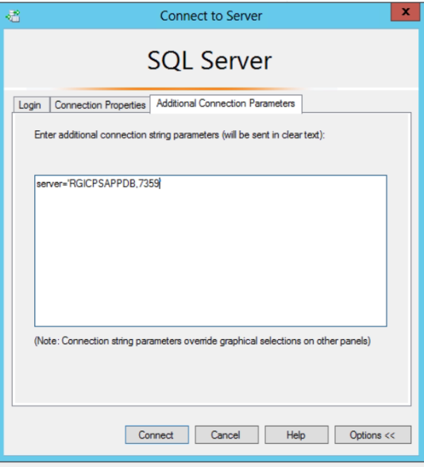

5 select Distribution database in front of publisher and then click ok.

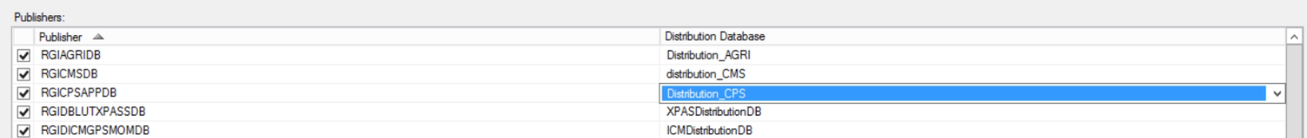

6 Connect Publisher server with server name and without port.

Go to Replication-> expand and right click on new Publication->

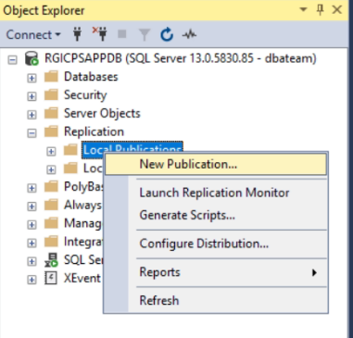

7 On New Publication wizard->

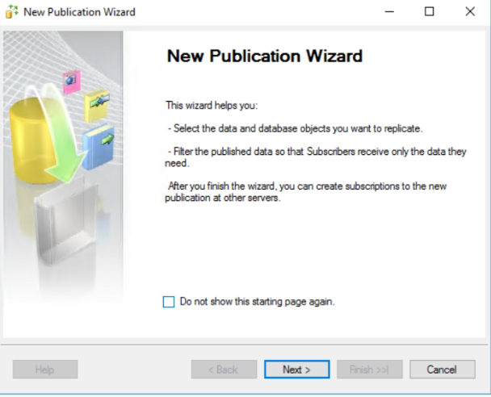

8 Click Next-> Click on 2nd option-> use following server as distributor ->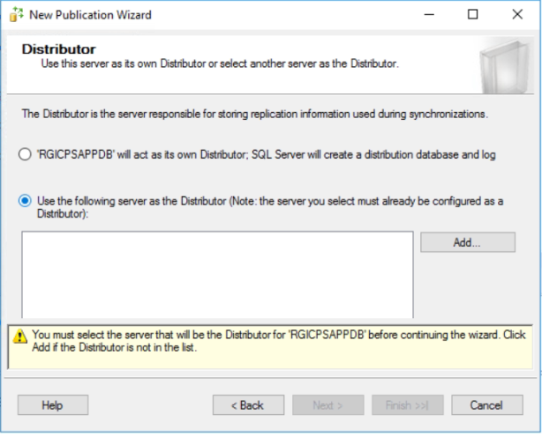

9 Add distributor server without port and with sql authentication ->

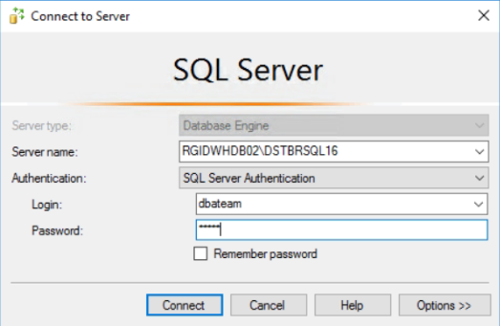

10 Provide distribution admin password (distributor_admin) in our case “same as SA” ->

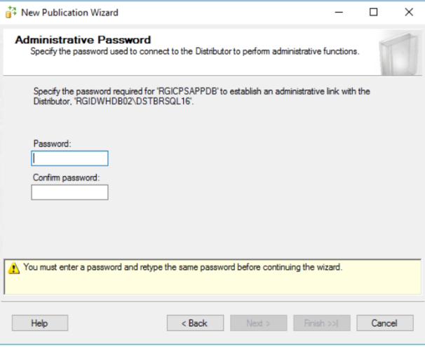

11 Click Next -> select Publication Database->

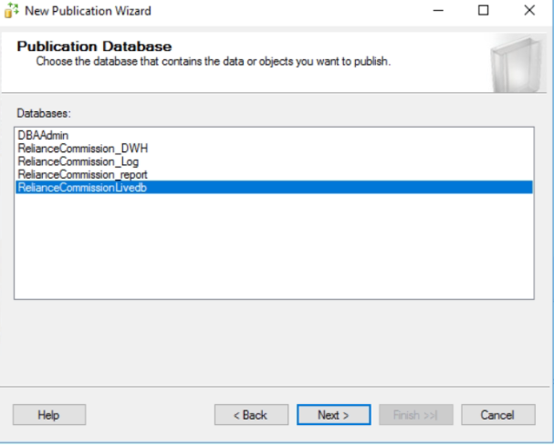

12 select publication type (in our case transactional pub).

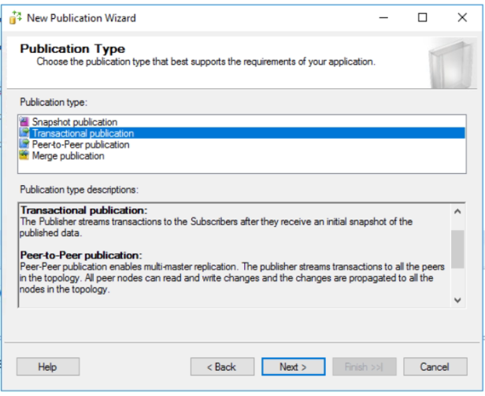

13 Now choose articles and click on checkbox (show only checked articles in the list).

And above article properties select (Set properties of highlighted table articles).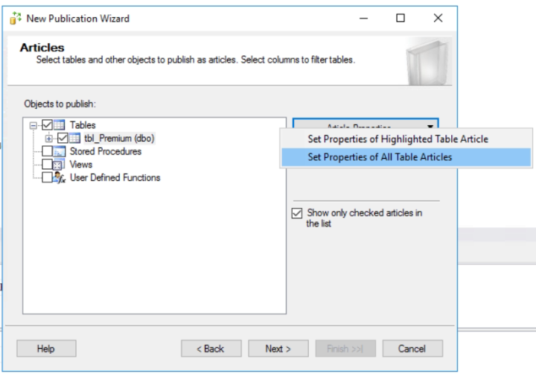

14 in article properties wizard choose “**copy Non Clustered Index from False to True**” -> click ok and Next.

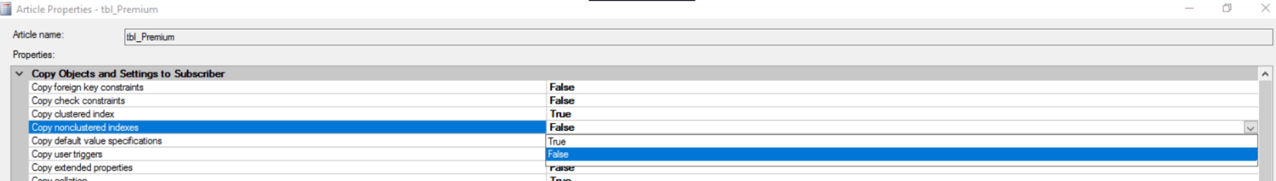

15 Not to select Anything in Filtered table rows -> Click Next.

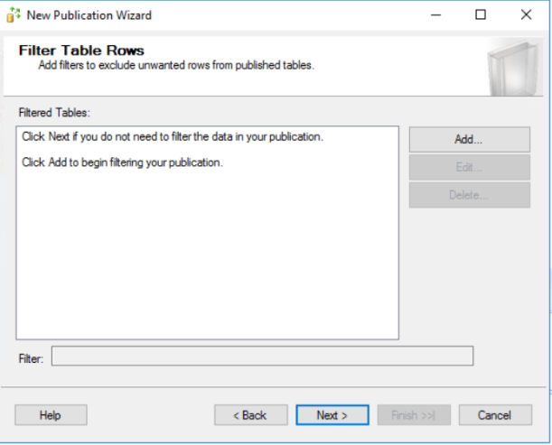

16 on Snapshot agent dialogue click on “**Crate snapshot immediately**”

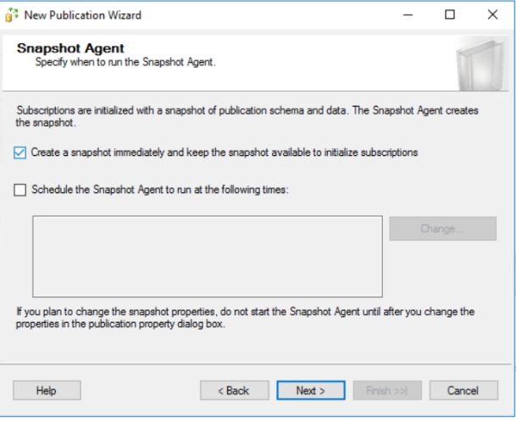

17 On Snapshot agent security ->

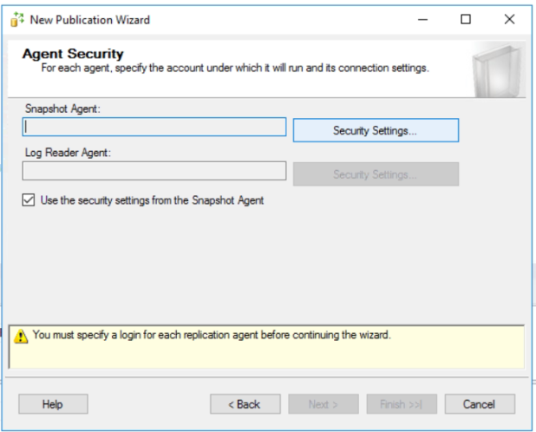

18 Security Settings-> choose run under sql agent service account and for to connect publisher use sysadmin sql account -> Click Ok.

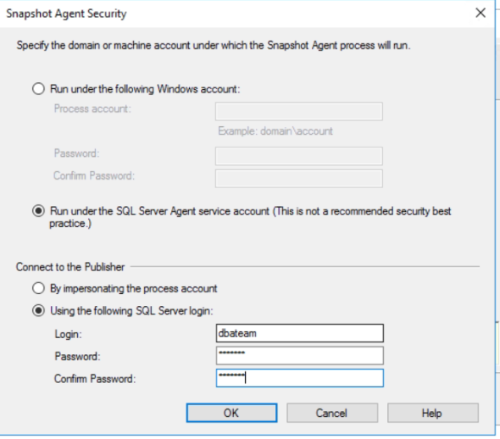

19 Click on Create the Publication -> Click Next.

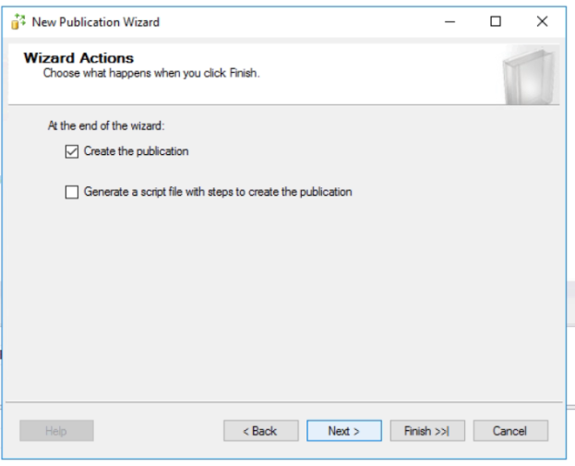

20 Provide Publication name and click Finish.

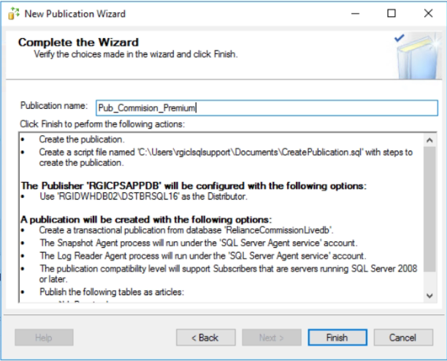

Done…

Configure Subscriber:

21 Create Subscription Database on Subscriber server. (**Simple Recovery**)

On folder we have created earlier.

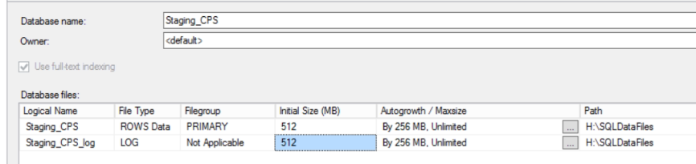

22 Connect Publisher server without port -> Under Replication ->

Expand Local Publication-> Click on New Subscription.

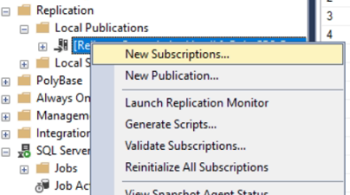

23 Select Publisher server -> select Database-> select Publication and click on next.

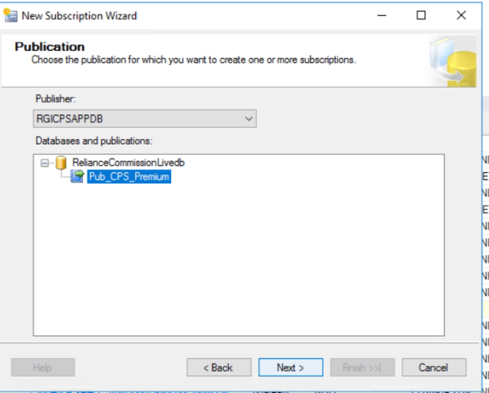

24 Here we select PUSH Subscription.

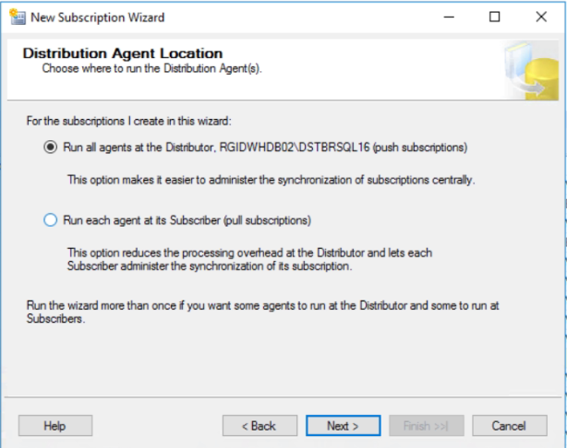

25 Select Subscriber and Subscription Database.

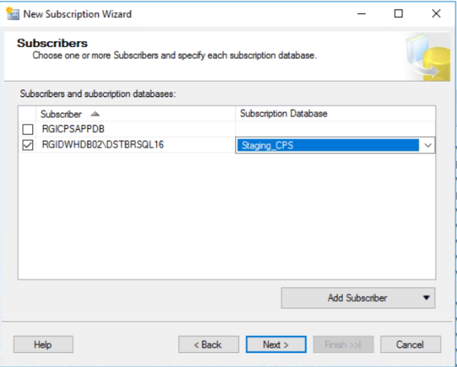

26 Click on (…) Dots.

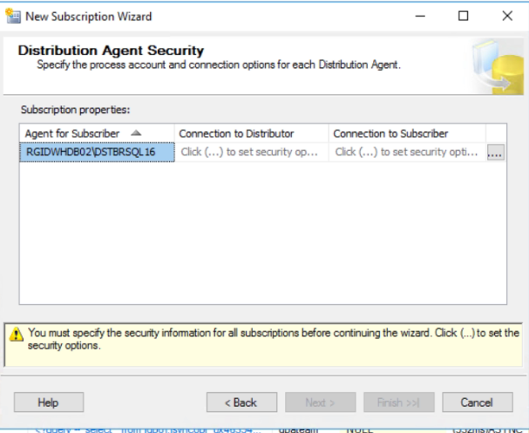

27 Select run under SQL agent service acc.-> connect to subscriber under sysadmin account SQL authentication. ->Click Ok & Next.

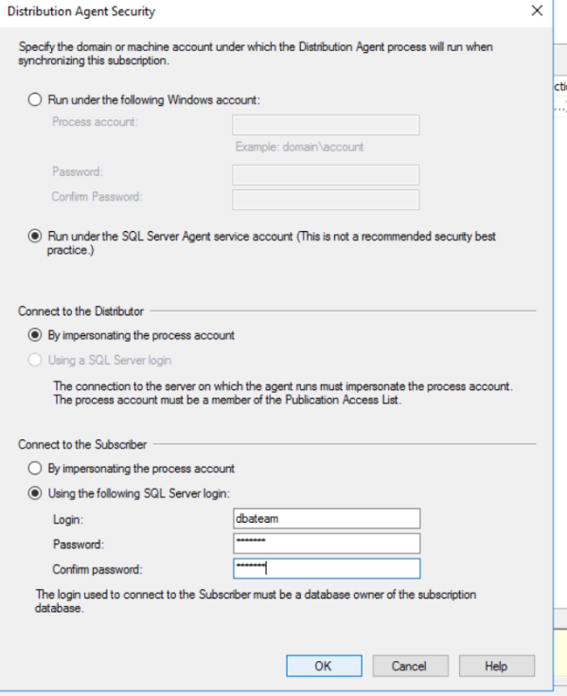

28 kept as run continuously

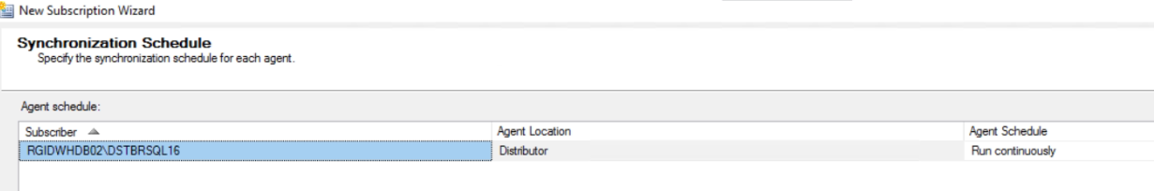

29 Initialize immediately.

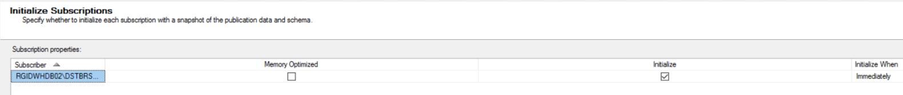

30 Click Next and Create Subscription. & Finish.

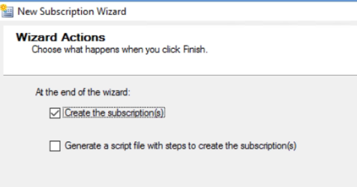

[How to Set Up Transactional Replication - Simple Talk (red-gate.com)](https://www.red-gate.com/simple-talk/databases/sql-server/database-administration-sql-server/how-to-set-up-transactional-replication/)

We faced issue and troubleshooting.

Faced issue while creating publication

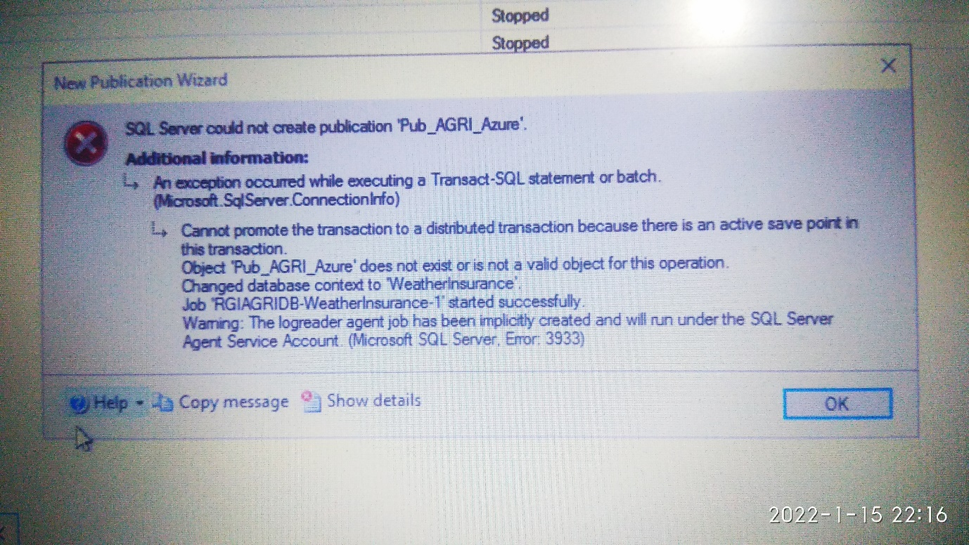

Troubleshooting:

We have disable user created tigger from msdb.sys jobs table from all servers -> Publisher, Distributor, Subscriber

Then We delete the replication which we have created by

1. Go to Distributer Properties
2. In general tab -> delete distributions database & click ok.
3. In Distributer Properties -> Publisher tab uncheck publisher &click ok.
4. On Publication server under -> local publication -> we have deleted subscription-> then publication
5. delete all sql jobs related to replication.
6. Drop subscriber and distributor database (**optional**).

Optional:-

1 If you get error like below

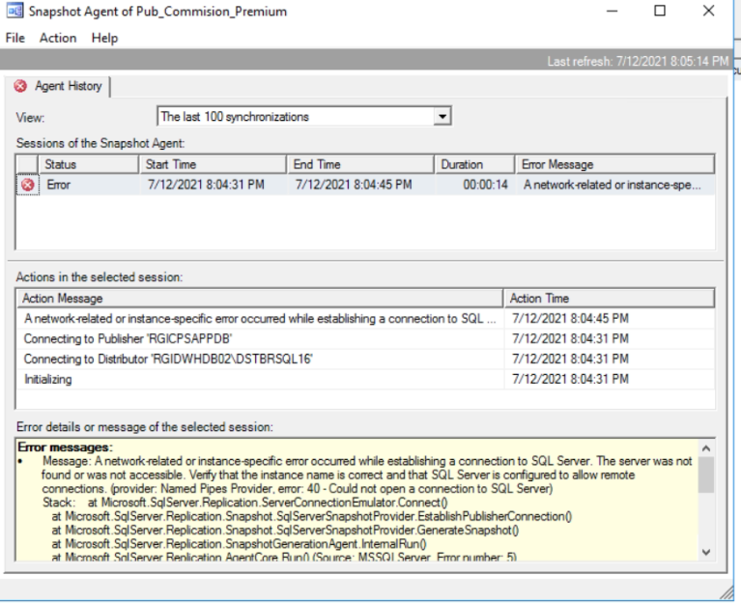

2 On all servers create alias server of each other servers involved in Replication in configuration manager for both 64 bit and 32 bit.

